|  |  |  |  |  |  |  |  |  |  |  |
| --- | --- | --- | --- | --- | --- | --- | --- | --- | --- | --- |
| MODEL | EPOCHS | **0.001** | TEST R2 | TRAIN R2 | **0.002** | TEST R2 | TRAIN R2 | **0.005** | TEST R2 | TRAIN R2 |
| **MPNN** |  | 32 | 0.47 | 0.57 | 32 | 0.68 | 0.86 | 32 | 0.743 | 0.90 |
|  | 50 | 64 | 0.7492 | 0.90 | 64 | 0.7491 | 0.89 | 64 | 0.747 | 0.90 |
|  |  | 128 | 0.738 | 0.89 | 128 | 0.7506 | 0.90 | 128 | 0.7437 | 0.9029 |
|  |  |  |  |  |  |  |  |  |  |  |
|  | 100 | 32 | 0.74 | 0.89 | 32 | 0.7458 | 0.90 | 32 | 0.74 | 0.90 |
|  |  | 64 | 0.749 | 0.90 | 64 | 0.747 | 0.90 | 64 | 0.748 | 0.90 |
|  |  | 128 | 0.748 | 0.90 | 128 | 0.748 | 0.905 | 128 | 0.747 | 0.906 |

**Table S1**

|  |  |  |  |  |  |  |  |  |  |  |
| --- | --- | --- | --- | --- | --- | --- | --- | --- | --- | --- |
| **ResGCN** |  | 32 | 0.75 | 0.93 | 32 | 0.74 | 0.92 | 32 | 0.75 | 0.93 |
|  | 50 | 64 | 0.741 | 0.91 | 64 | 0.747 | 0.93 | 64 | 0.748 | 0.937 |
|  |  | 128 | 0.7488 | 0.93 | 128 | 0.7488 | 0.93 | 128 | 0.7480 | 0.93 |
|  |  |  |  |  |  |  |  |  |  |  |
|  | 100 | 32 | 0.7480 | 0.93 | 32 | 0.7487 | 0.93 | 32 | 0.7490 | 0.93 |
|  |  | 64 | 0.7481 | 0.9356 | 64 | 0.7488 | 0.9362 | 64 | 0.7489 | 0.9374 |
|  |  | 128 | 0.7485 | 0.9369 | 128 | 0.7487 | 0.9377 | 128 | 0.7483 | 0.93 |
| **GraphSAGE** |  | 32 | 0.736 | 0.902 | 32 | 0.7502 | 0.931 | 32 | 0.7511 | 0.933 |
|  | 50 | 64 | 0.7494 | 0.93 | 64 | 0.7499 | 0.9365 | 64 | 0.7486 | 0.9373 |
|  |  | 128 | 0.748 | 0.937 | 128 | 0.747 | 0.936 | 128 | 0.7501 | 0.939 |
|  |  |  |  |  |  |  |  |  |  |  |
|  | 100 | 32 | 0.748 | 0.934 | 32 | 0.749 | 0.938 | 32 | 0.7488 | 0.9396 |
|  |  | 64 | 0.7491 | 0.9368 | 64 | 0.7492 | 0.9380 | 64 | 0.7493 | 0.9392 |
|  |  | 128 | 0.7494 | 0.9378 | 128 | 0.7492 | 0.9393 | 128 | 0.7480 | 0.9402 |
| **GCN** |  | 32 | -1.3340 | -1.2635 | 32 | -1.47 | -1.41 | 32 | 0.53 | 0.65 |
|  | 50 | 64 | -1.7112 | -1.6576 | 64 | 0.5126 | 0.6395 | 64 | 0.6993 | 0.8166 |
|  |  | 128 | 0.273 | 0.399 | 128 | 0.709 | 0.812 | 128 | 0.71 | 0.824 |
|  |  |  |  |  |  |  |  |  |  |  |
|  | 100 | 32 | -0.1688 | -0.0540 | 32 | 0.6064 | 0.7313 | 32 | 0.7130 | 0.8259 |
|  |  | 64 | -0.4660 | -0.3612 | 64 | 0.7140 | 0.8258 | 64 | 0.7136 | 0.8261 |
|  |  | 128 | 0.7027 | 0.8190 | 128 | 0.7139 | 0.8261 | 128 | 0.7147 | 0.8264 |
| **GAT** |  | 32 | 0.3839 | 0.5144 | 32 | 0.7041, | 0.8682 | 32 | -0.0850 | 0.0183 |
|  | 50 | 64 | 0.6904 | 0.8519 | 64 | 0.0717 | 0.1834 | 64 | 0.2450 | 0.3636 |
|  |  | 128 | 0.4326 | 0.5665 | 128 | 0.6722 | 0.8302 | 128 | 0.3225 | 0.4456 |
|  |  |  |  |  |  |  |  |  |  |  |
|  | 100 | 32 | 0.4437 | 0.5782 | 32 | -0.2331 | -0.1351 | 32 | 0.0318 | 0.1371 |
|  |  | 64 | 0.6675 | 0.8251 | 64 | -0.0116 | 0.0944 | 64 | 0.6710 | 0.8298 |
|  |  | 128 | 0.4708 | 0.6068 | 128 | 0.4946 | 0.6313 | 128 | 0.6562 | 0.8118 |
| **GATV2** |  | 32 | 0.59 | 0.74 | 32 | 0.74 | 0.92 | 32 | 0.73 | 0.91 |
|  | 50 | 64 | 0.74 | 0.92 | 64 | 0.72 | 0.89 | 64 | 0.73 | 0.90 |
|  |  | 128 | 0.74 | 0.92 | 128 | 0.73 | 0.90 | 128 | 0.7068 | 0.91 |
|  |  |  |  |  |  |  |  |  |  |  |
|  | 100 | 32 | 0.73 | 0.90 | 32 | 0.62 | 0.84 | 32 | 0.66 | 0.87 |
|  |  | 64 | 0.71 | 0.91 | 64 | 0.73 | 0.90 | 64 | 0.72 | 0.93 |
|  |  | 128 | 0.744 | 0.9251 | 128 | 0.75 | 0.9367 | 128 | 0.719 | 0.923 |
| **GIN** |  | 32 | 0.4288 | 0.5085 | 32 | 0.4897 | 0.5336 | 32 | 0.4820 | 0.5355 |
|  | 50 | 64 | 0.5240 | 0.5657 | 64 | 0.5420 | 0.6021 | 64 | 0.4453 | 0.5181 |
|  |  | 128 | 0.5354 | 0.5779 | 128 | 0.5081 | 0.5482 | 128 | 0.4510 | 0.5175 |
|  |  |  |  |  |  |  |  |  |  |  |
|  | 100 | 32 | 0.4562 | 0.5570 | 32 | 0.4655 | 0.5620 | 32 | 0.4585 | 0.5479 |
|  |  | 64 | 0.5008 | 0.5962 | 64 | 0.5293 | 0.5714 | 64 | 0.5164 | 0.5500 |
|  |  | 128 | 0.5076 | 0.6016 | 128 | 0.5416 | 0.5936 | 128 | 0.4920 | 0.5308 |

***Table S1*.** Comparison of graph-based models (GAT, GCN, GIN, and GraphSAGE) evaluated under various hyperparameter configurations. Performance metrics (R², RMSE, MAE) are reported for different combinations of learning rates (0.001, 0.0002, 0.005), epochs (50, 100), and hidden dimensions (32, 64, 128).

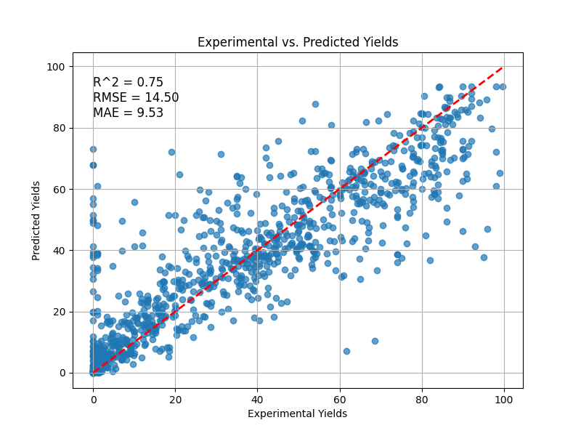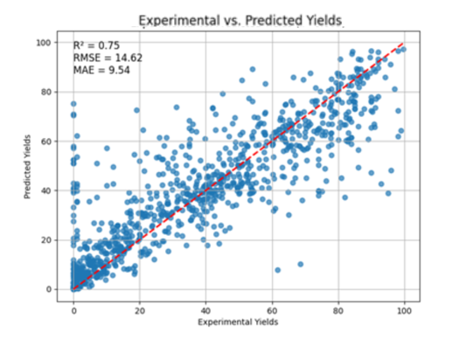

(A)MPNN (B) RESGCN

1. 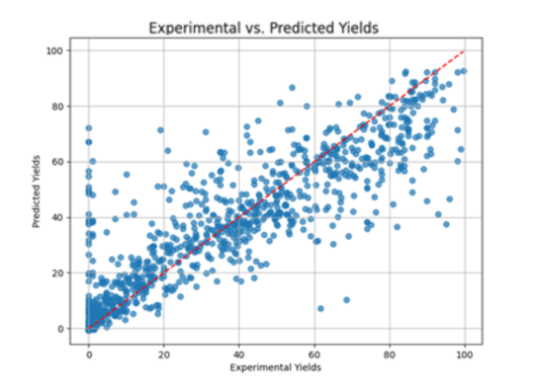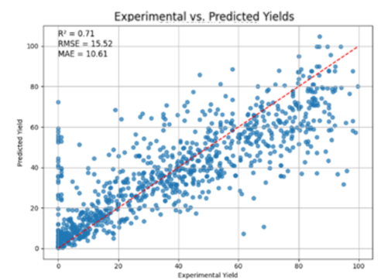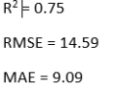 GraphSAGE (D) GCN

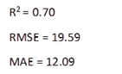 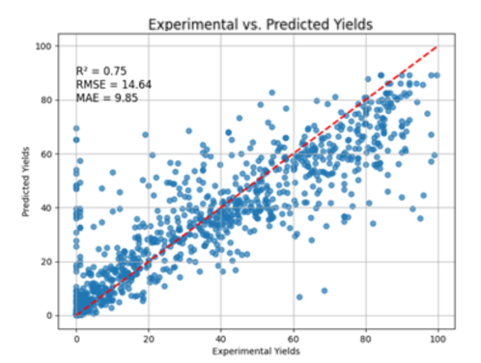

(E) GATV2 (F) GAT

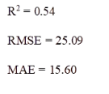

***Figure S1.***Scatter plots showing predicted versus experimental reaction yields for each graph-based model (GAT, GCN, GIN, GraphSAGE) using their respective optimized hyperparameters. Each model was trained and evaluated under various configurations of learning rate(0.001,0.002,0.005), number of epochs(50,100), and hidden layer dimensions(32,64,128).

(G) GIN